Multilingual sign language interpreter

Department of Multidisciplinary engineering
Vishwakarma Institute of Technology
Upper Indira Nagar , bibwewadi , Pune - 411 037

Puja Abhijeet Chavan
puja.cholke@vit.edu
Department of Multidisciplinary engineering
Vishwakarma Institute of Technology

Atharv Balaji Mali
atharv.mali21@vit.edu
Department of Multidisciplinary engineering
Vishwakarma Institute of Technology

Shubham Shivaji Mali
shubham.mali21@vit.edu
Department of Multidisciplinary engineering
Vishwakarma Institute of Technology

Gitesh Prakash Mane
gitesh.mane21@vit.edu
Department of Multidisciplinary engineering
Vishwakarma Institute of Technology

Pratik Masani
pratik.masani212vit.edu
Department of Multidisciplinary engineering
Vishwakarma Institute of Technology

Abstract –
Currently there are more than 1.5 billion deaf people in the world , and they are more than twenty percent of the population world.Among them there are more than 430 million people who are suffering from hearing loss.And till the year 2050 this count can reach upto 700 million.So signed language is the way by which these people can do communication with the normal people.The difference in signed language can be find from region to region all over the world.Multiple signed languages can be seen in multiple areas.
Like the classification of the signed languages has been done like American signed language,Indo pakistani sign language,russian signed language etc.
Each language has its own techniques for communication,has different kinds of signs,grammer ect. This paper provides aid in communicating with those having vocal and speaking disabilities .As Sign language is an important communication tool for deaf people and people who are suffering from difficulties communicating with society , It is a virtual language that conveys information using hand gestures , hand shapes and movement of hand .This
Paper aims to provide an application which can do multi lingual signed language detection and conversion of that text into multiple languages using text to speech API so that deaf people can easily communicate with normal people.

Keywords ( sign language,hand gestures,multilingual )

Introduction-

There is always a challenge of communicating with the deaf people. According to the World Health Organization, 328 million people worldwide suffer from hearing loss, with 32 million being children. Sign language is the daily language of communication between deaf and dumb people. It is the most comfortable and natural way for deaf and dumb people to communicate, and it is also the primary tool for special education schools to teach and convey ideas[1]. So signed language has been developed so that deaf people can also do communication and can develop their personality like the normal ones.But these sign languages are not the same it differs from region to region and from country to country all around the world,which results in a lack of communication when a deaf person is traveling and is unaware of the regional sign language,and that isn’t the only problem they face in our day to day life we come across very few or if any person who can interpret sign languages and he/she isn’t deaf , amongst them there are even fewer who can understand multiple sign languages so a language barrier can be seen in normal and deaf people so to overcome this language barrier multilingual signed language detection application and conversion of that signed language into text and from that text to speech has been developed.As the technology is enhancing day by day this application is so simple so that any person can handle this application and can communicate with the deaf people.
Multilingual functionality and text to speech conversion helps to understand the feelings and emotions of deaf people more accurately and more precisely.

This language barrier also interferes with the Inclusion of deaf or hard of hearing students in public schools.In light of growing concerns about the full inclusion of deaf or hard of hearing children in general education in the absence of adequate communication and social supports (Frishberg, 1990; Schrag, 199I), research is needed to clarify the roles and responsibilities of the key individuals who make inclusion possible[3].This application will also helps towards the full inclusion of deaf or hard of hearing students in public schools and this will also help the regular students learn sign language from a very young age and thus making it a lot easier for the deaf to communicate in the future. Communication is a critical component in implementing inclusive education.
The design and selection of 3D modeled hand gestures for human-computer interaction should adhere to natural language principles while also optimizing gesture contrast and recognition[5].

Literature Review–

The quality of interpretation is a critical issue in sign language interpreting. According to research, the quality of interpretation can be influenced by a number of factors, including the interpreter's ability level, familiarity with the subject matter, and the interaction between the deaf person and the interpreter (Parrill, 2011).
A sign language recognition system that employs Hidden Markov Models (HMMs), Artificial Neural Networks (ANNs), and template matching. Using a skin colour segmentation technique, the system initially recognises hand forms and records hand movements in sign language films. It then extracts information like hand trajectory and hand orientation, which are fed into HMMs and ANNs for recognition.On two sign language datasets, the system achieves recognition rates of 87.9% and 92.6%, respectively. The paper finds that a hybrid strategy combining HMMs, ANNs, and template matching can increase the accuracy and resilience of sign language recognition[4].
The development of mobile applications for sign language interpreting is one field of study. Mobile apps offer the ability to enable instant access to sign language interpretation for a variety of reasons such as education, communication, and information dissemination. Huang, Kao, and Wu (2017) investigated the efficacy of a smartphone app called "SignHelper" for Chinese Sign Language interpretation. The application was proven to be helpful in providing accurate and quick sign language interpretation, according to the study[7].
The use of augmented reality (AR) technology in sign language interpreting is another field of study. AR technology superimposes digital content on the physical world, allowing for real-time sign language interpretation. Kurz and colleagues (2020) investigated the application of augmented reality (AR) technology in a museum context, where visitors might utilize AR technology to get sign language interpretation of exhibits. The study discovered that augmented reality technology was an excellent technique of providing sign language interpretation in a museum context[8]. Aside from mobile applications and augmented reality (AR), researchers have looked into the use of artificial intelligence (AI) in sign language interpretation. Artificial intelligence (AI) can be used to recognise and interpret sign language gestures into text or spoken language. Sharma and colleagues (2021) created an AI-based sign language recognition system for Indian Sign Language in their study. The study discovered that the technology recognised sign language motions with excellent accuracy[9].

Existing Solutions–

In the present scenario the existing system are not very expandable as they provide with only a single sign language interpretation which means this solution cannot be used widely across different regions of the world and they also don't provide text speech conversion into the desired language of the user.

Proposed Solution–

The proposed system provides the user with many different options such as the user can select the required regional sign language to interpret so that there’s no miscommunication while interpreting the the said language and the user can also select there required language for text to speech conversion for there better understanding making this project way more expandable then the currently existing solutions.

Methodology–

The proposed system works as a user-friendly android application using java.
It consists of two different applications for interpreting the sign language one is real time interpretation and the other is via capturing the image and then interpreting.
This application also provides us with different options for sign language interpretation as there are multiple sign languages depending on the region such as Indian Sign Language(ISL),American Sign Language (ASL) British, Australian and New Zealand Sign Language (BANZSL) etc. In real time interpretation the application interprets the sign language frame by frame continuously and then interprets the selected sign language accordingly and these interpreted signs are arranged respectively in the order they are interpreted, and then these interpreted signs are converted from text to speech in order to give out a proper sentence.The text to speech conversion also includes the conversion of language from English to Hindi, Marathi and several other languages spoken in India so as to provide good means of communication all around.

Merits–

- The User Interface is easy to interpret and user friendly and provides us with the choice of regional sign language.
- The application provides us with real time capturing and at the same time interpreting the selected sign language into the choice regional language via text to speech conversion.
- The application is easily accessible to all thus making it a very handy solution for everyone.

Flowchart–
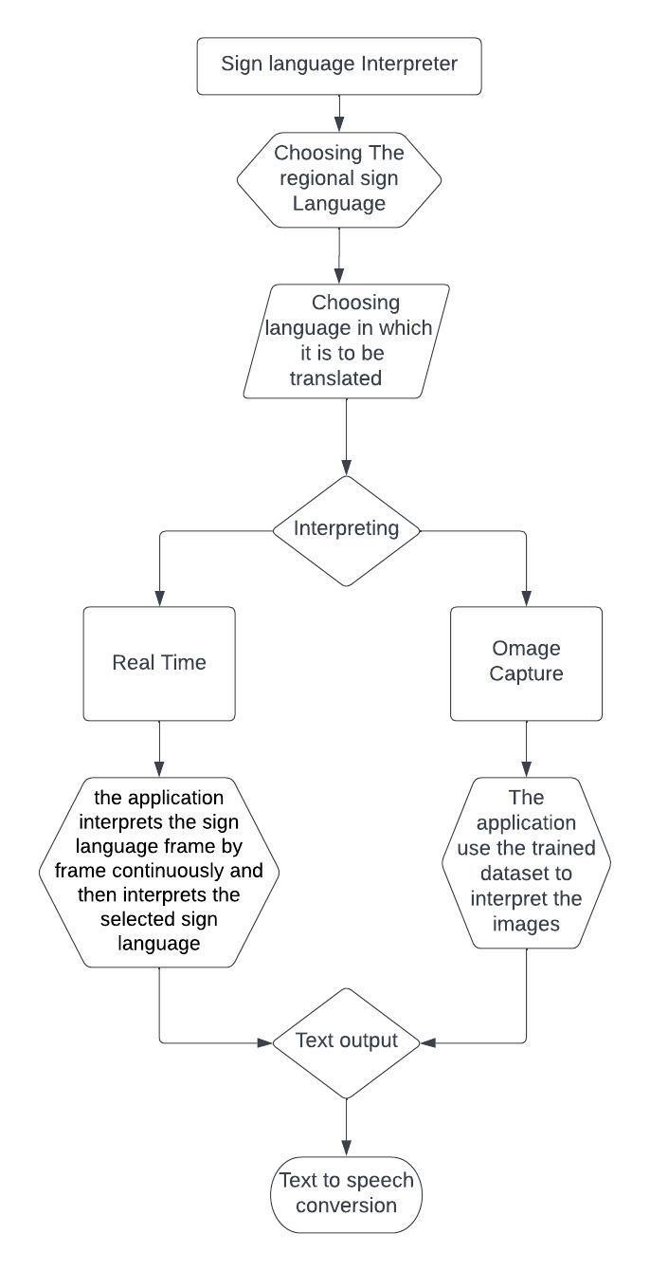Fig.1. Schematic diagram of the project

Results –

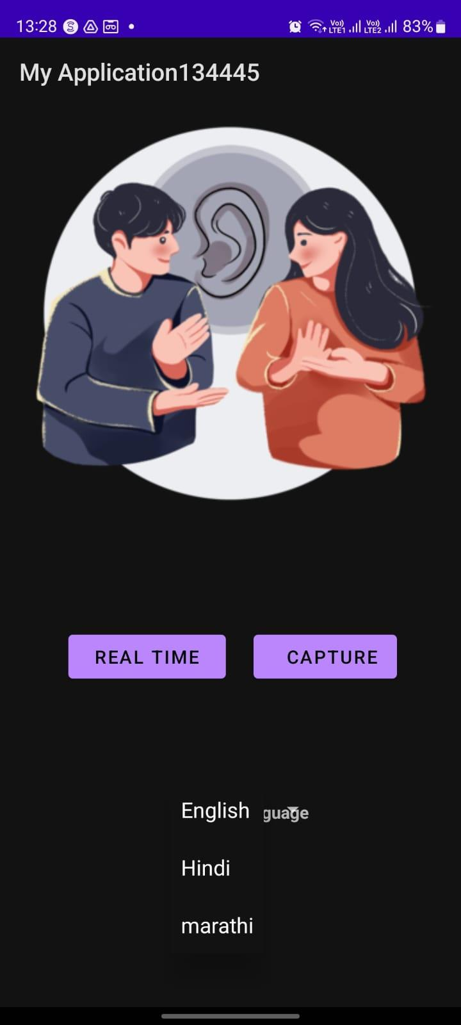
Fig.2 GUI of the application
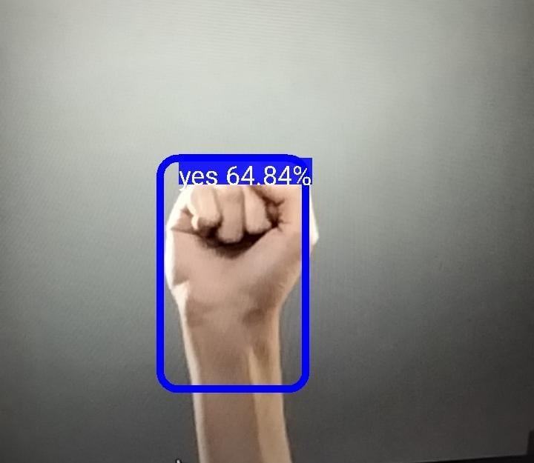
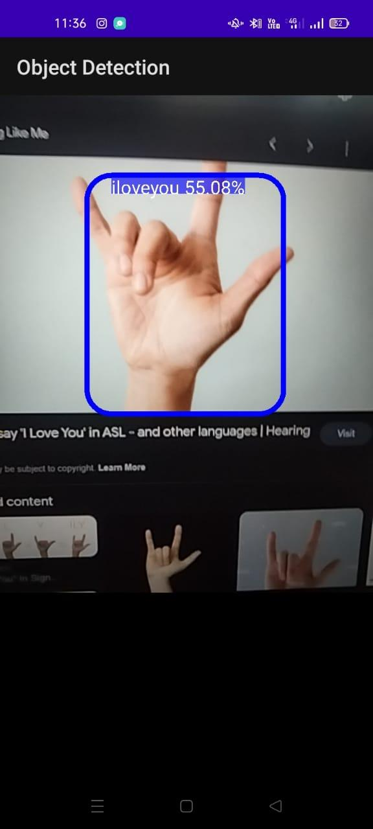
Fig.3 Real time interpretation

Conclusion –

From the above research we have inferred many things as well as proposed a system that provides all the amenities provided by the previous solution and more. One of the very important inference that this research came upon was that the existing system for sign language interpretation doesn’t provide with different more than one sign language interpretation as there are different regional sign languages, also the existing solution doesn’t provide with text to speech conversion into desired language, both of the above mentioned problems are countered in this demonstration which makes is a very reliable solution for specially abled peoples.

Future Scope –

The future scope of sign language detection is promising and could have significant impacts on the lives of individuals who use sign language as their primary means of communication. Here are some potential areas of growth and development .The development of more advanced machine learning algorithms, coupled with advances in computer vision technology, is likely to lead to more accurate and reliable sign language detection systems. As such, the future of sign language detection looks very promising, and there is a lot of scope for research and development in this area.

References –

[1] S. He, "Research of a Sign Language Translation System Based on DeepLearning," 2019 International Conference on Artificial Intelligence and Advanced Manufacturing (AIAM), Dublin, Ireland, 2019, pp. 392-396, doi: 10.1109/AIAM48774.2019.00083.

[2] V. H. Iyer, U. M. Prakash, A. Vijay and P. Sathishkumar, "Sign Language Detection using Action Recognition," 2022 2nd International Conference on Advance Computing and Innovative Technologies in Engineering (ICACITE), Greater Noida, India, 2022, pp. 1682-1685, doi: 10.1109/ICACITE53722.2022.9823484.

[3] Jones, B. E., Clark, G. M., & Soltz, D. F. (1997). Characteristics and Practices of Sign
Language Interpreters in Inclusive Education Programs. Exceptional Children, 63(2), 257–268. https://doi.org/10.1177/001440299706300209

[4] A. Kumar, K. Thankachan and M. M. Dominic, "Sign language recognition," 2016 3rd International Conference on Recent Advances in Information Technology (RAIT), Dhanbad, India, 2016, pp. 422-428, doi: 10.1109/RAIT.2016.7507939.

[5] David Rempel, Matt J. Camilleri and David L. Lee, “The design of hand gestures for human–computer interaction: Lessons from sign language interpreters” Int J Hum Comput Stud. 2015 October ; 72(10-11): 728–735.
doi:10.1016/j.ijhcs.2014.05.003.

[6] Jones, B. E., Clark, G. M., & Soltz, D. F. (1997). Characteristics and Practices of Sign Language Interpreters in Inclusive Education Programs. Exceptional Children, 63(2), 257–268. https://doi.org/10.1177/00144029970630020

[7]Huang, K. C., Kao, Y. T., & Wu, H. C. (2017). Evaluating the effectiveness of a mobile application for Chinese Sign Language recognition. Computers & Education, 109, 24-35.

[8]Kurz, M. J., Boring, S., Trausner, C., & Prinz, W. (2020). Using augmented reality to provide sign language interpretation in a museum setting. ACM Transactions on Accessible Computing, 13(1), 1-24.

[9]Sharma, S., Singh, S., & Dey, S. (2021). Sign language recognition using deep learning for Indian Sign Language. SN Computer Science, 2(4), 1-12.

